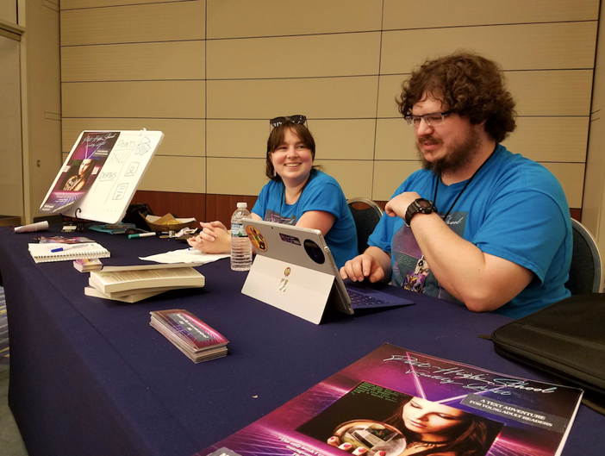
Book Title(s):
GOOD DIFFERENT (Scholastic 2023) – MG
POST-HIGH SCHOOL REALITY QUEST (Rare Bird 2017) – YA
DROWNING IN THE FLOATING WORLD (Press 53 2020) - Adults
Types of visits offered: classroom visits, visiting writer fellowships, hands-on writing workshops, library visits, panels, virtual visits, individual office hours with writing students, excerpt readings, Q&As and conversations, bookstore visits, book club visits
Subjects of programs: poetry, fiction, video games, voice, publishing your work, environmental storytelling, use of form in writing, neurodivergence
Popular Programs Offered Include:
Environmental Storytelling: How Video Games Taught Me How to Write - Through the power of images, we can convey a whole narrative in a short space. Games like Deus Ex: Mankind Divided and Gone Home use environmental storytelling to give us pieces of characters’ lives. In this workshop, we’ll discuss examples of games that tell stories through objects, and go into our own writing exercises inspired by video games.

Unlocking Your Voice in Writing - Some writers feel a pressure that to be “a good writer” they need to use elevated, poetic or flowery language. However, the language of our experiences can be the most powerful tool in our writing. In this workshop, we’ll read examples of writing that uses “the language of the experience,” as well as take part in a “translation” exercise to explore finding our unique voice.

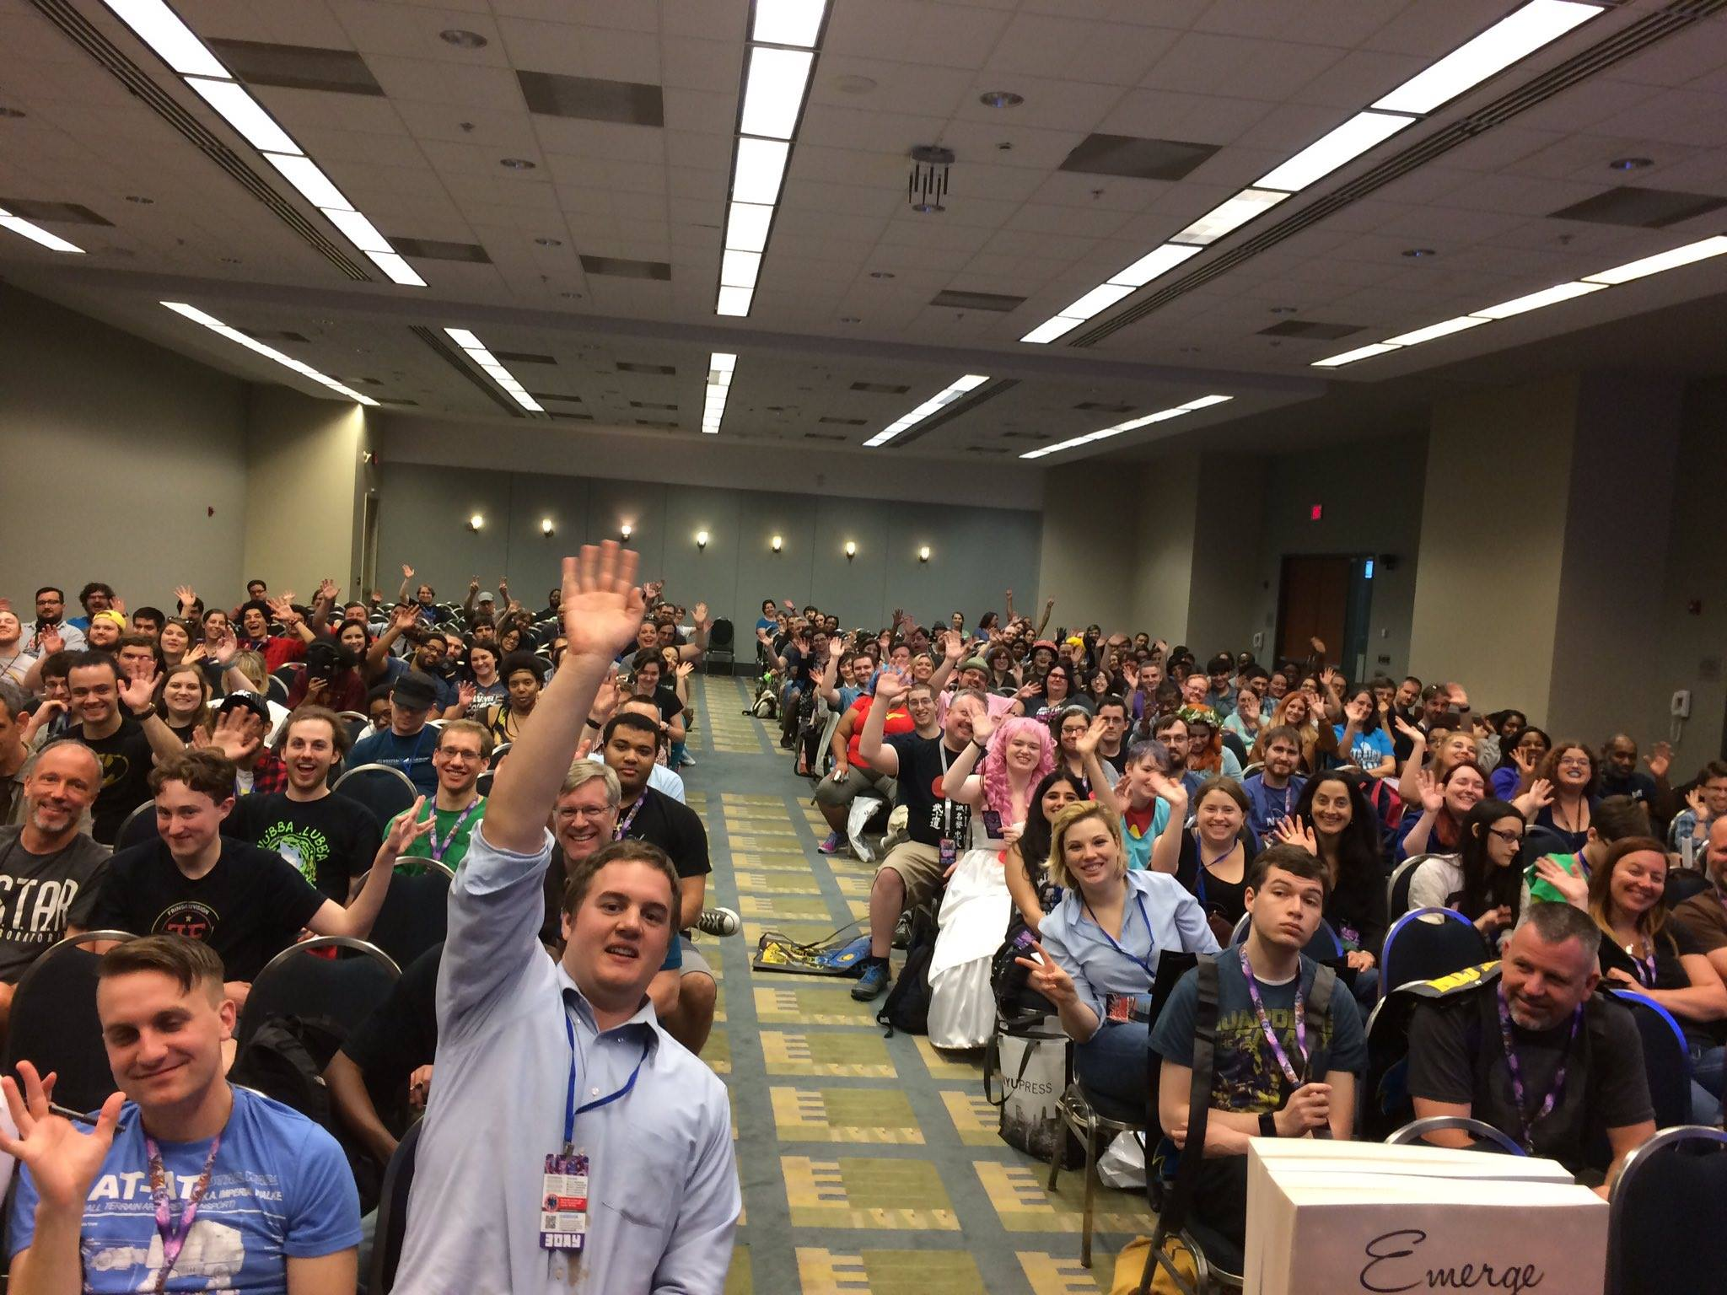Getting Your Foot in the Door: Publishing in Literary Magazines - Want to submit your work to magazines but don't know how? In this workshop, we'll talk about what literary magazines are, what editors are looking for in submissions, have a “translation” exercise, tips on how to prepare a submission, as well as how to handle rejections. The skills you learn in this session can easily apply to other publication realms, including writing to agents and editors of small book presses. All participants will receive a complimentary magazine of their choice.

Hooking Your Reader: Writing A Killer First Line - Most editors of both magazines and presses will say that they read the first, last and middle page of a story before deciding if they want to read more. Potential readers are even less forgiving. When I pick up a new book, if the first line doesn’t hook me, I probably won’t continue reading. So how do we snag our readers and make them want to read more? In this workshop, we’ll look at examples of powerful first lines and discuss strategies for selecting a powerful first line. Feel free to bring the first line of your story or novel for a mini first-line “workshop.”
Custom Presentations Available: Yes
Approximate costs: virtual visits start at $50, in-person at $500
For a full list of available programs, please visit: http://www.megedenbooks.com/visits/

